**ASSIGNMENT**

**V.S.B. Engineering College,Karur**

**Department Of Electronics And Communication Engineering**

**Title: SmartFarmer - IoT Enabled Smart Farming Application**

**Name:** Bharathkumar.D

**Problem:**

Make s smart Home in Tinkercad using 2+ sensors, LED, Buzzers in single code and circuit

**Circuit:**

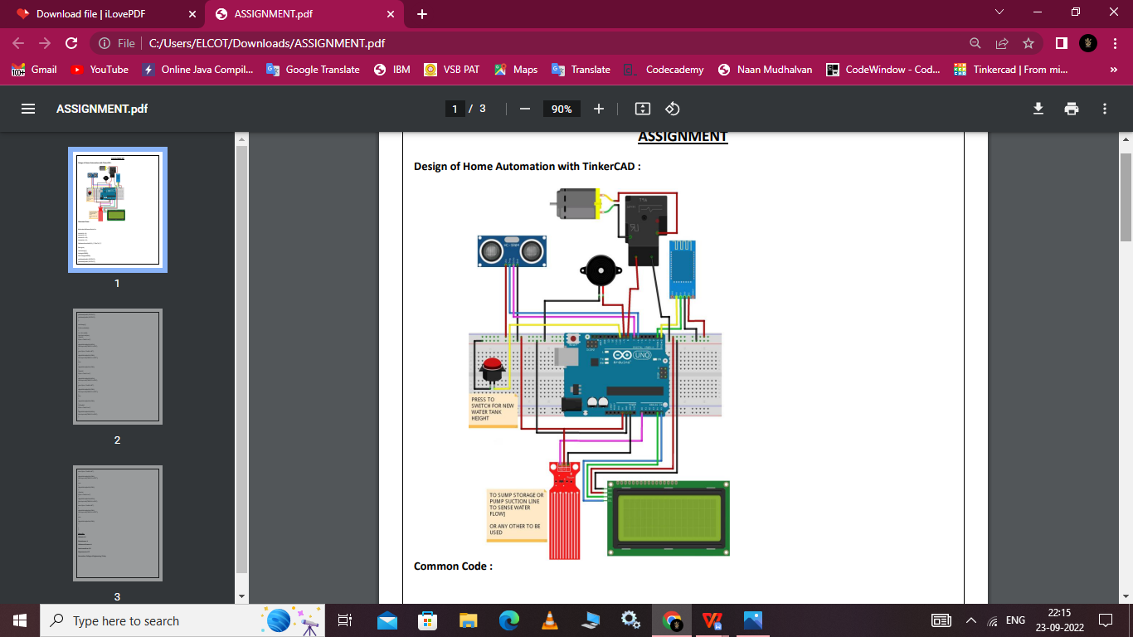

**Code:**

#include<SoftwareSerial.h> int bulb1 = 8;

int bulb2 = 9; int bulb3 = 10; int bulb4 = 11;

SoftwareSerial bt(0,1); /* (Rx,Tx) */ String str;

void setup() { bt.begin(9600); Serial.begin(9600);

pinMode(bulb1,OUTPUT); pinMode(bulb2,OUTPUT);pinMode(bulb3,OUTPUT); pinMode(bulb4,OUTPUT);

}

void loop() {

if (bt.available())

{

str = bt.read(); Serial.println(str);

//bulb1

if(str==”bulb1 on”)

{

digitalWrite(bulb1,HIGH); Serial.println(“BUlB 1 is ON”);

}

else if(str==”bulb1 off”)

{

digitalWrite(bulb1,LOW); Serial.println(“BUlB 1 is OFF”);

}

else

{

digitalWrite(bulb1,LOW);

}

//bulb2

if(str==”bulb2 on”)

{

digitalWrite(bulb2,HIGH); Serial.println(“BUlB 2 is ON”);

}

else if(str==”bulb2 off”)

{

digitalWrite(bulb2,LOW); Serial.println(“BUlB 2 is OFF”);

}

else

{

digitalWrite(bulb2,LOW);

}

////bulb3

if(str==”bulb3 on”)

{

digitalWrite(bulb3,HIGH); Serial.println(“BUlB 3 is ON”);

}

else if(str==”bulb3 off”)

{

digitalWrite(bulb3,LOW); Serial.println(“BUlB 3 is OFF”);

}

else

{

digitalWrite(bulb3,LOW);

}

//bulb4

if(str==”bulb4 on”)

{

digitalWrite(bulb4,HIGH); Serial.println(“BUlB 4 is ON”);

}

else if(str==”bulb4 off”)

{

digitalWrite(bulb4,LOW); Serial.println(“BUlB 4 is OFF”);

}

else

{

digitalWrite(bulb4,LOW);

}

}

}